

Dear ...... ,

I would like to extend my sincerest gratitude for your valuable feedback on our recent discussions. Your insights have been incredibly helpful, and I truly appreciate the time and effort you dedicated to sharing your thoughts.
It was a pleasure to engage in such a constructive exchange, and I am enthusiastic about the prospect of working together. Your expertise in mediation will undoubtedly bring significant value to our collaboration. I am confident that, with our combined efforts, we will achieve excellent results.
Please rest assured that I remain fully committed to ensuring a smooth and successful partnership. Should there be any further details or clarifications you would like to address, I am at your disposal.
Once again, thank you for your continued support, and I look forward to the exciting work ahead.

Yours faithfully,

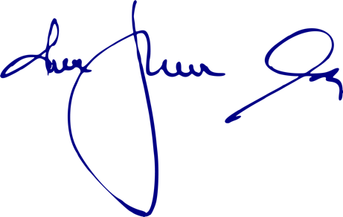

www.birokamediacioert.hu info@birokamediacioert.hu
Bírók a Mediációért Egyesület
Association of Judges for Mediation

Dr. Percze Szilvia
nemzetközi koordinátor
International Coordinator

Dr. Parti Mónika
elnök, BAM
President of BAM

